**Qualitative & Quantitative Observations**

1. Complete the following table by indicating if each of the observations is either a qualitative or quantitative observation. Briefly explain / justify your answer. **[5 Marks]**

|  |  |  |
| --- | --- | --- |
| **Observation** | **Circle the type  of Observation** | **Provide a reason** |
| The colour of grass is green | Qualitative or  Quantitative |  |
| The block has a mass of 10g | Qualitative or  Quantitative |  |
| When the rock was placed in the graduated cylinder the volume increased  by 23 ml | Qualitative or  Quantitative |  |
| The sample of metal was flat and hard | Qualitative or  Quantitative |  |
| The oil floated on top of the water | Qualitative or  Quantitative |  |

**Physical Properties**

1. Match the definition for each of the Physical Properties listed below. Write the definition letter beside each property. **[8 Marks]**

|  |  |  |  |
| --- | --- | --- | --- |
| **Physical Property** | **Definition Letter** |  | **Definition Choices** |
| Lustre | ______ |  | 1. Describes how well a liquid substance flows. (e.g. watery or thick like honey) |
| Transparency | ______ |  | 1. Describes the shape of a solid substance. (e.g. powder, crystals, chunky) |
| State | ______ |  | 1. Describes if a solid substance can be flattened out (e.g. bendable or rigid) |
| Crystal Form | ______ |  | 1. Describes how well the surface of a substance reflects light (e.g. shiny or dull) |
| Texture | ______ |  | 1. Describes if a solid substance can be stretched into a thin wire |
| Malleability | ______ |  | 1. Describes if the substance is a solid, liquid, or gas |
| Ductility | ______ |  | 1. Describes how well light shines through a substance. (e.g. clear, transparent, opaque) |
| Viscosity | ______ |  | 1. Describes how the surface of a substance feels. (e.g. rough, soft, smooth) |

Marks: /47 Observations: /Level

1. Use the two samples provided by your teacher. Complete the table by observing the samples and recording the physical properties you can see for each sample.

**[8 Marks]**

|  |  |  |
| --- | --- | --- |
| **Question** | **Sample #1** | **Sample #2** |
| Letter of the Sample Jar |  |  |
| Name of Sample on Jar |  |  |
| Physical Property #1   * What physical property do you see? * Explain what you see |  |  |
| Physical Property #2   * What is another physical property that you see? * Explain what you see |  |  |
| Physical Property #3   * What is another physical property that you see? * Explain what you see |  |  |
| Is it a Metal or Non-Metal?   * Write Metal or Non-Metal * Explain your answer |  |  |

**Measuring Mass**

1. You will be using the same two objects provided by your teacher for the rest of this skills test. Record the ID (e.g. letter and number) of each object below:  
   * ID of **regular** object: __________
   * ID of **irregular** object: __________
2. Find the mass of each object using the triple beam balances. **[8 Marks]**

|  |  |  |  |  |
| --- | --- | --- | --- | --- |
| **Object ID** | **Trial #1**  **(mass in g)** | **Trial #1**  **(mass in g)** | **Trial #1**  **(mass in g)** | **Average**  **(mass in g)** |
|  |  |  |  |  |
|  |  |  |  |  |

1. Demonstrate how to measure mass using a triple beam balance. Wait for your teacher to call you for this demonstration:

**Relearn Level1 Level2 Level3 Level4**

**Measuring Volume**

1. Measure the volume of your **regular** shaped object. (*Use the same object as before.*)  
   1. ID of **regular** object: __________
   2. Measurements & Calculations (Show your work): **[4 Marks]**
   3. Volume of **regular** object: __________
2. Measure the volume of your **irregular** shaped object. (*Use the same object as before*.)  
   1. ID of **irregular** object: __________
   2. Measurements & Calculations (Show your work): **[4 Marks]**
   3. Volume of **irregular** object: __________
3. Demonstrate how to measure the volume of your **irregular** shaped object. Wait for your teacher to call you for this demonstration:

**Relearn Level1 Level2 Level3 Level4**

**Calculating Density & Applying Density**

1. 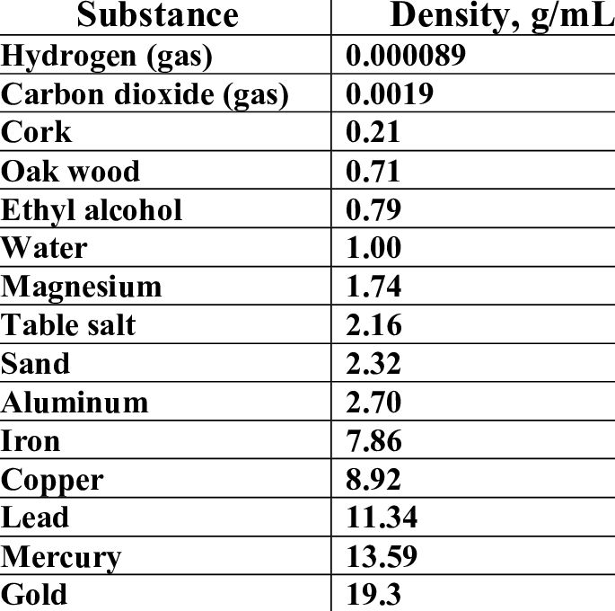Calculate the density of your **regular** shaped object.   
   Show all of your work below. **[3 Marks]**
2. Use the density table to predict what your **regular** shaped   
   object is made of. Justify your answer. **[2 Marks]**
3. Calculate the density of your **irregular** shaped object.   
   Show all of your work below. **[3 Marks]**
4. Use the density table to predict what your **irregular** shaped   
   object is made of. Justify your answer. **[2 Marks]**